**Scenario: Launch instagram**

**Step: Launch "instagram" WebPage - PASS**

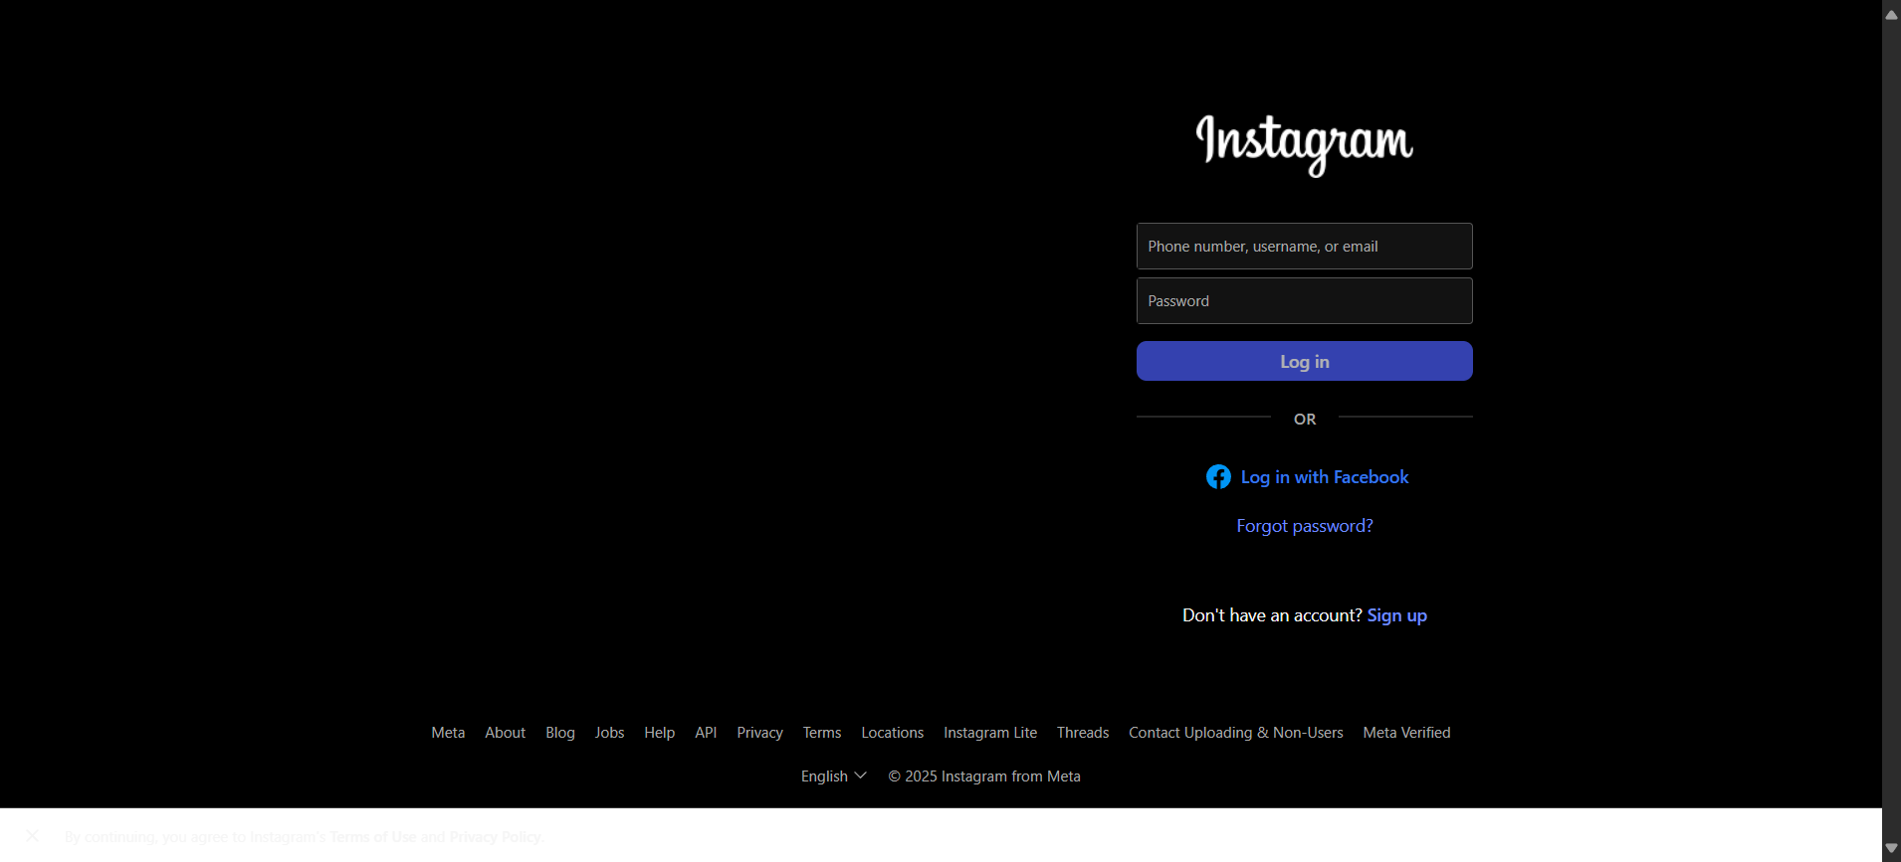

**Step: Enter UserName "subbu" into "Username1" textbox at "LoginPage" page - PASS**

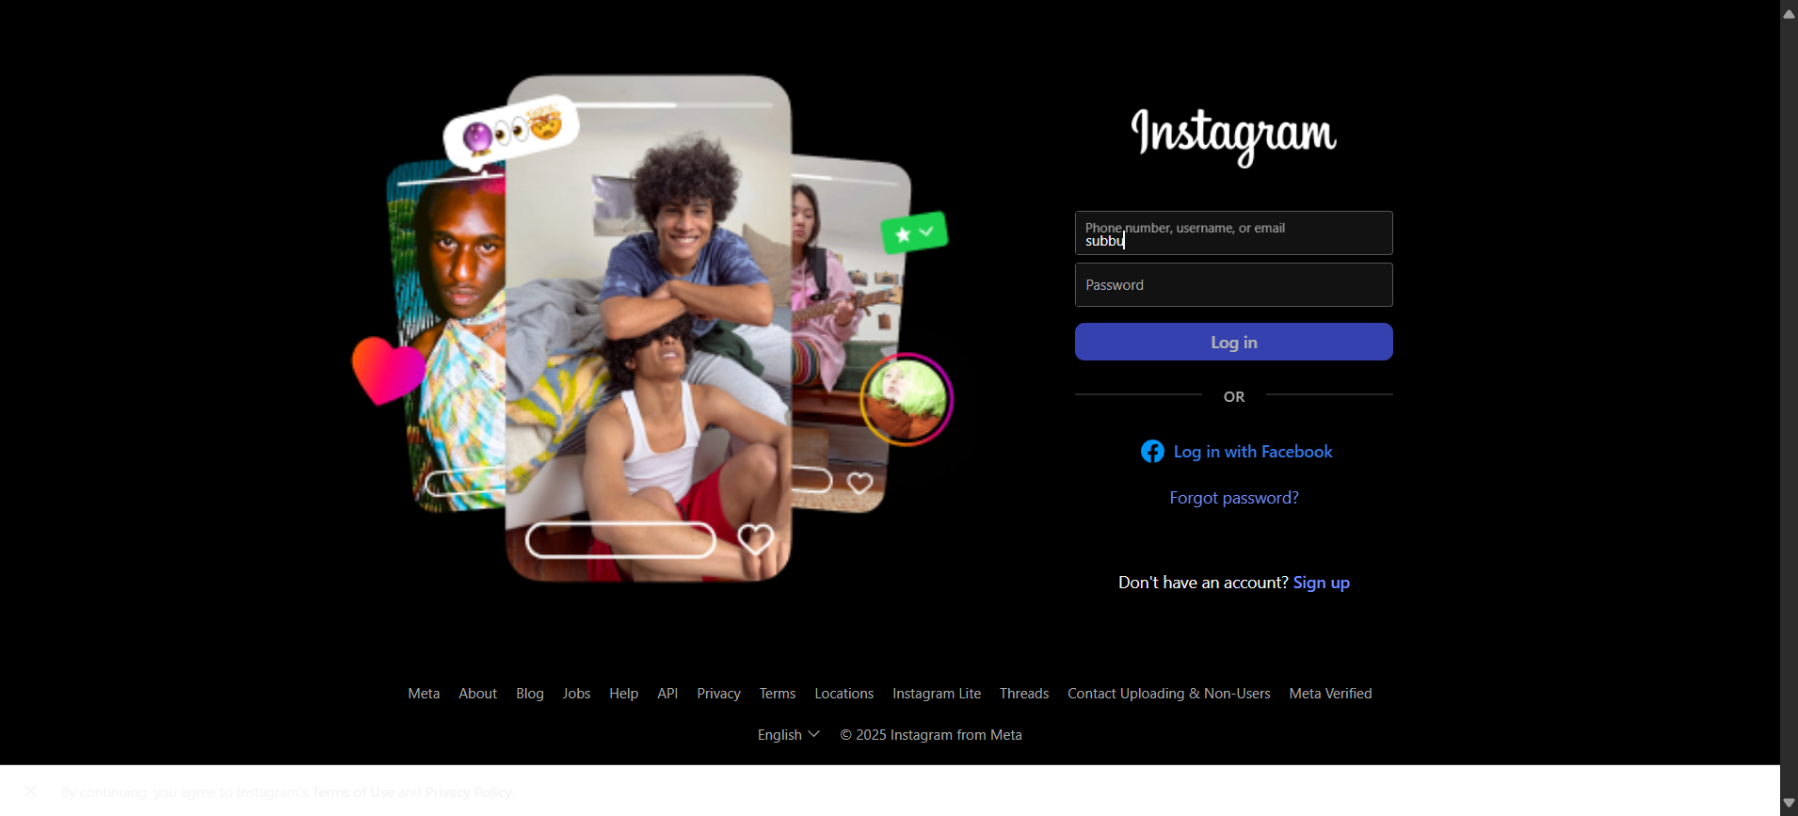

**Step: Enter Password "pass_a" into "Password2" textbox at "LoginPage" page - PASS**

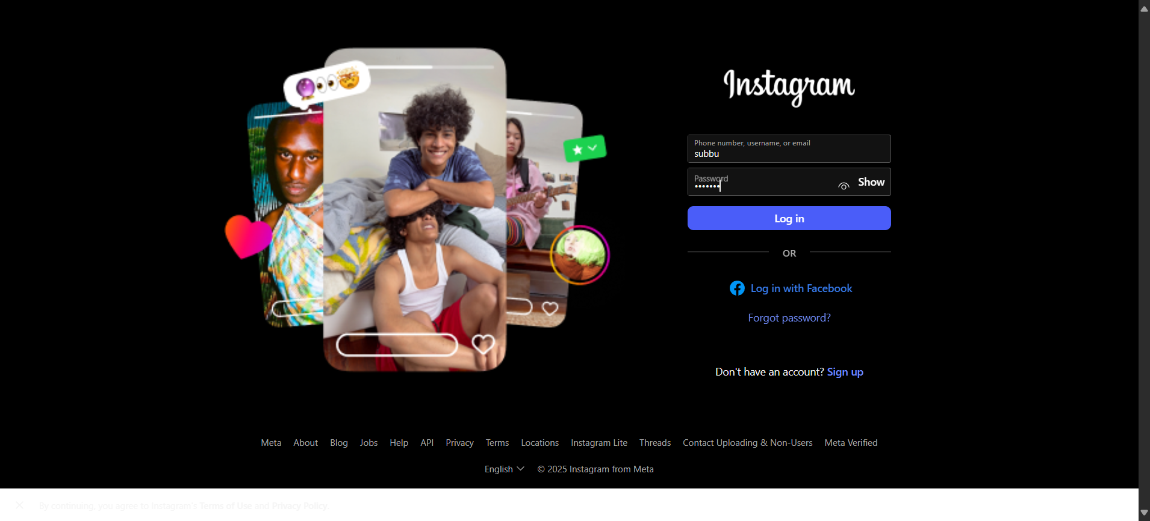

**Step: Click "login_button1" element at "LoginPage" page - PASS**

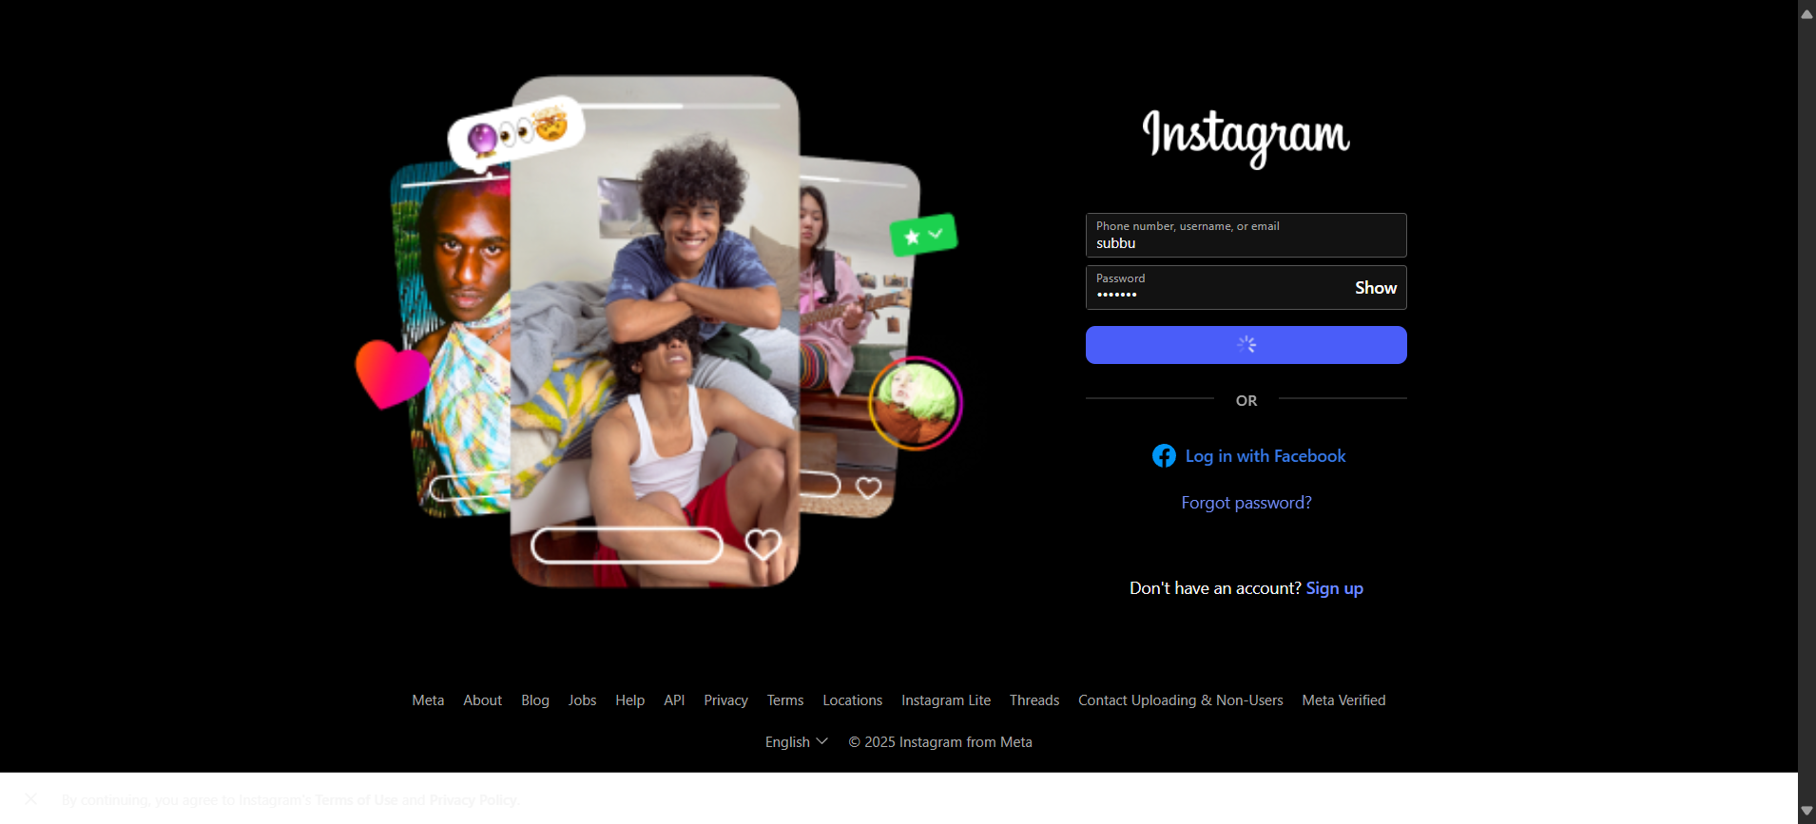

**Execution Summary:  
Total Steps: 4  
Passed: 4  
Failed: 0**

**Step: Launch "instagram" WebPage - PASS**

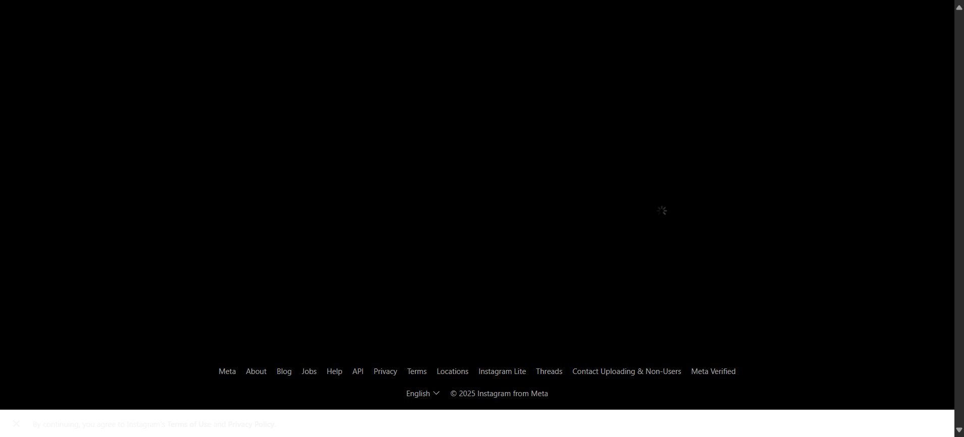

**Step: Enter UserName "arise" into "Username1" textbox at "LoginPage" page - PASS**

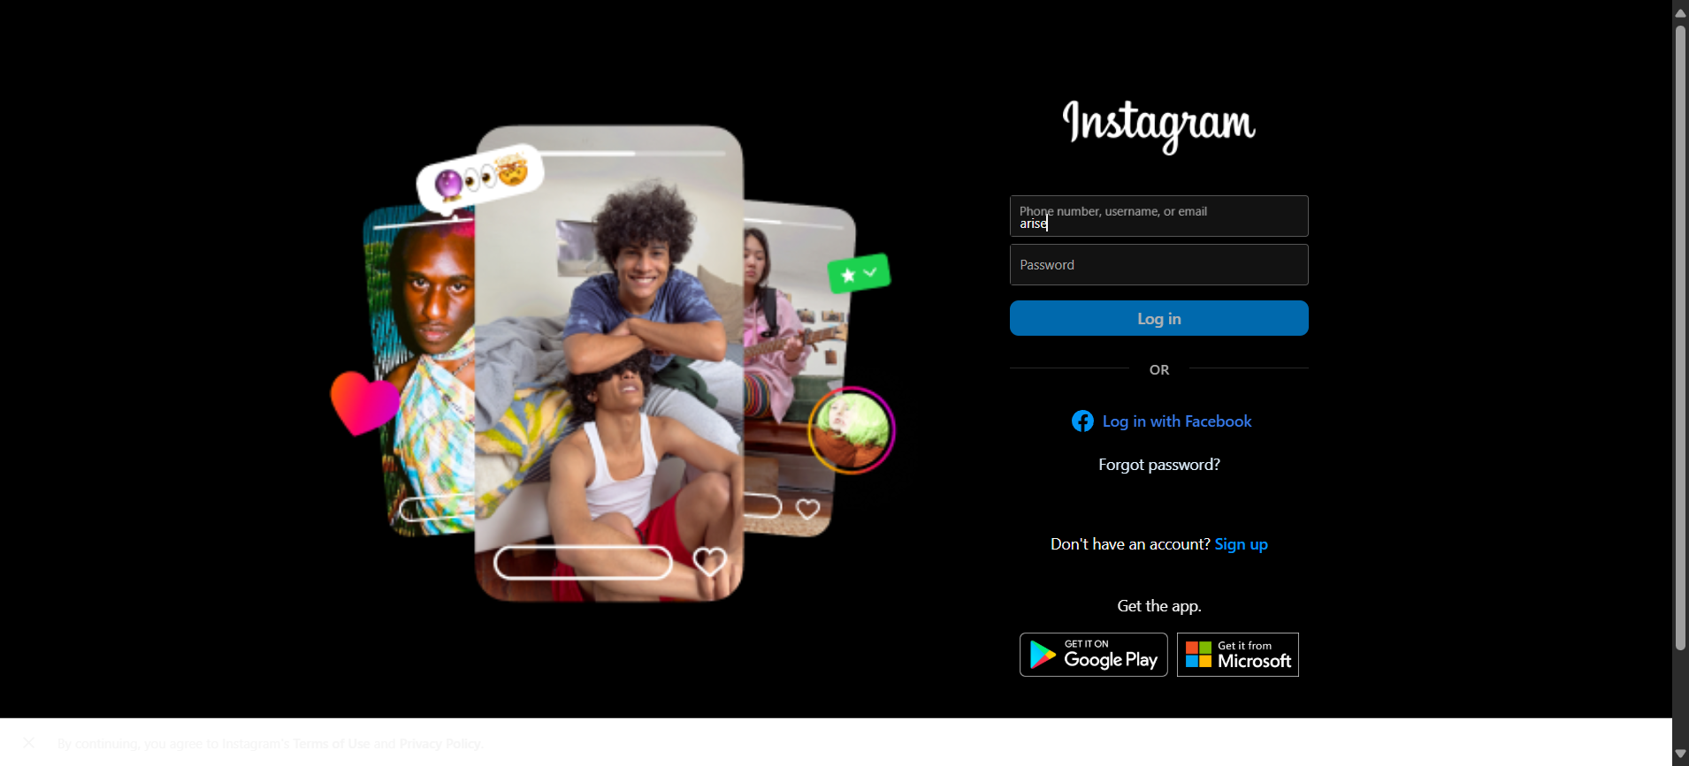

**Step: Enter Password "pass_b" into "Password2" textbox at "LoginPage" page - PASS**

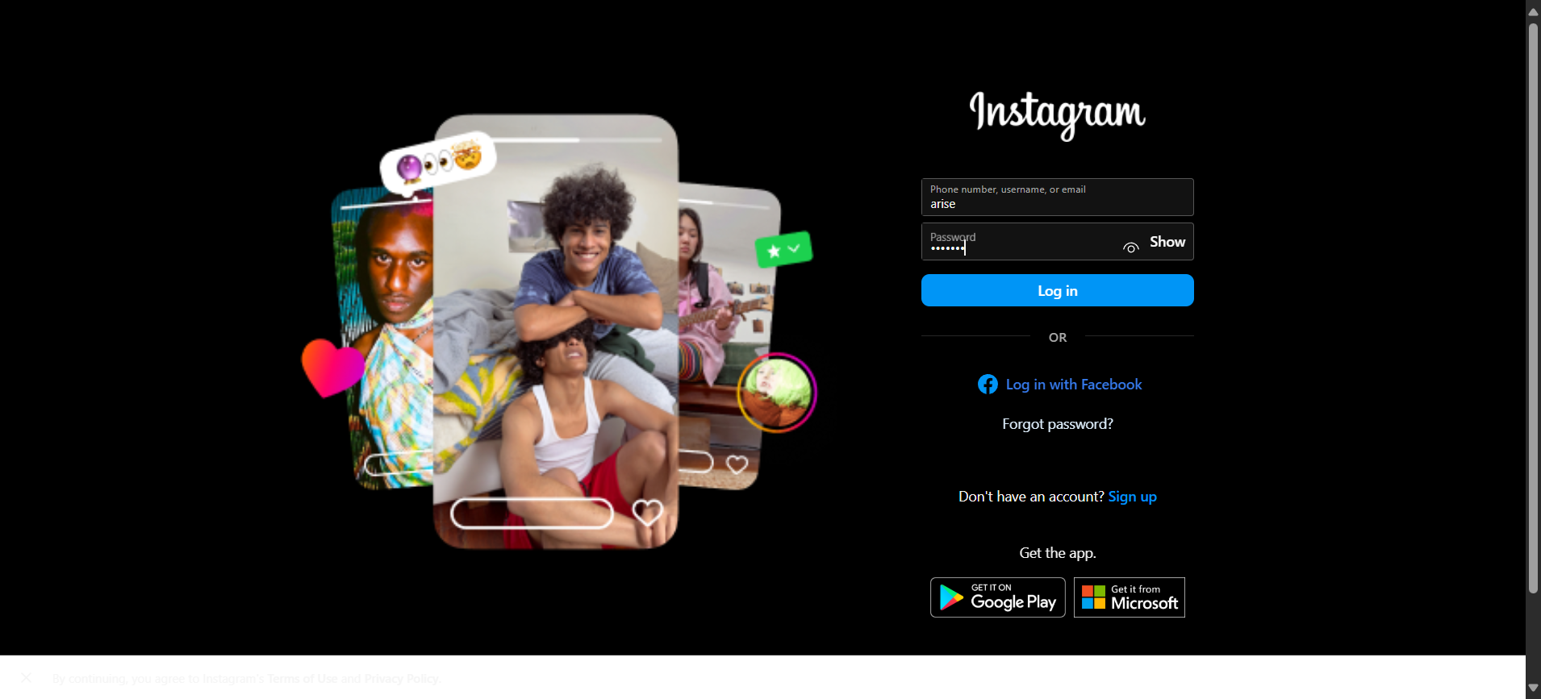

**Step: Click "login_button1" element at "LoginPage" page - PASS**

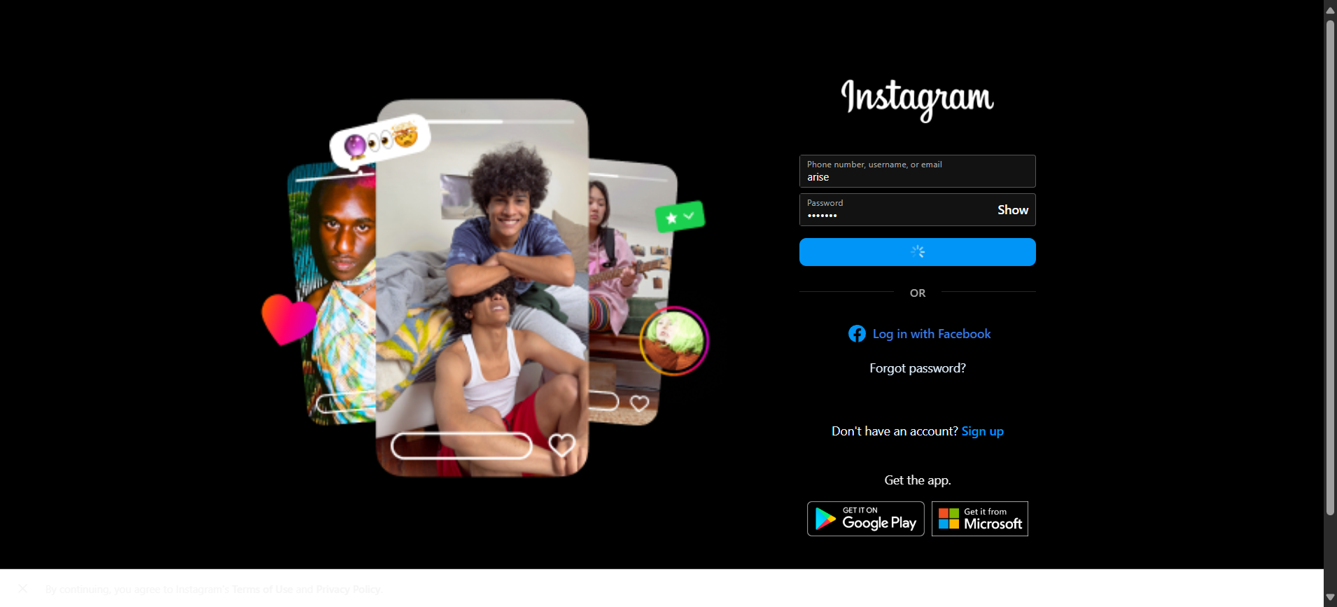

**Execution Summary:  
Total Steps: 8  
Passed: 8  
Failed: 0**